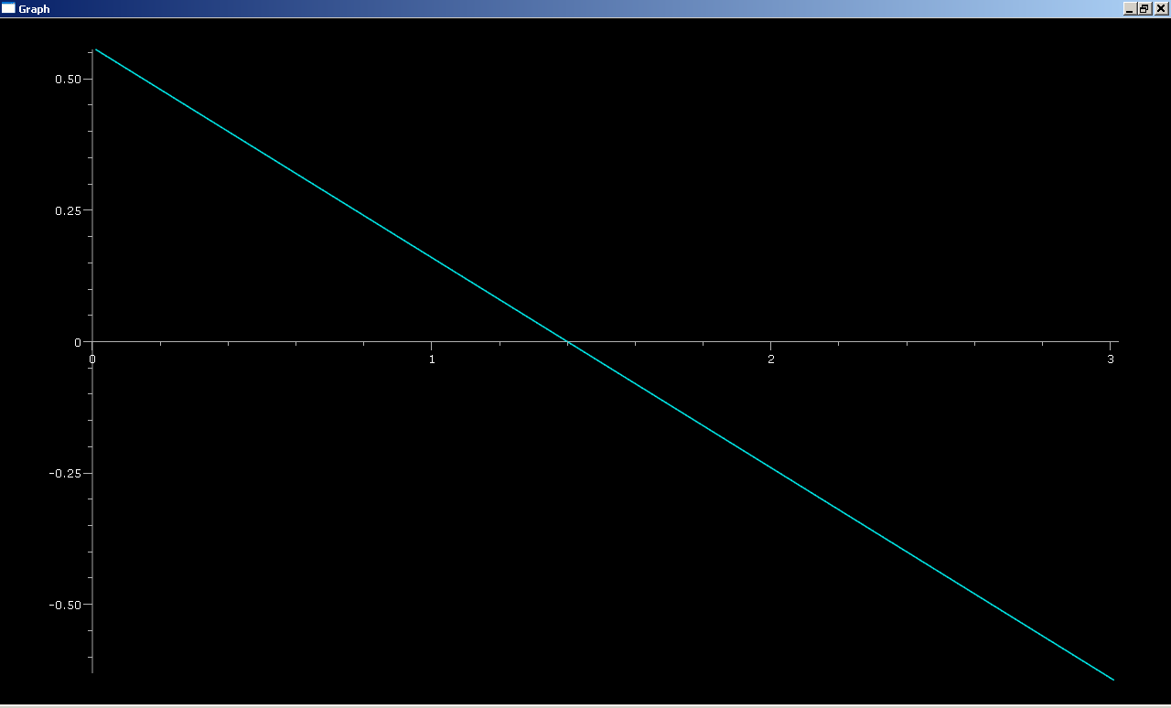

Momentum Data:
t= 0 cart.p= <0.556, 0.08, 0>
t= 1.0 cart.p= <0.156, 0.08, 0>
t= 2.0 cart.p= <-0.244, 0.08, 0>
t= 3.0 cart.p= <-0.644, 0.08, 0>
Lab Questions
1)
Initial Momentum vector:
t= 0 cart.p= <0.556, 0.08, 0>
Final Momentum vector:
t= 0.01 cart.p= <0.552, 0.08, 0>
Delta Momentum = <-0.004,0,0> kg m/s
2)
Final Momentum – Initial Momentum= Delta Momentum
Delta Momentum= Net Force*Delta Time
Net Force= <-.4,0,0>
Delta Time= .01
Net Force* Delta Time= <-0.004,0,0>
3)
My Calculations show that the Net Force*Delta time= Delta Momentum.
4)
The Net Force is only exerted in the x direction, so the momentums in the y and z directions do not change. This is because there is no acceleration so there is no change in velocity.

